Séance 9: jeudi 4 avril - distanciel

- Correction of the American Dream Homework

- THEME 1: Ellis Island

- Read the introduction about Ellis island and the document below and try to reformulate it with our own words: what was Ellis Island?
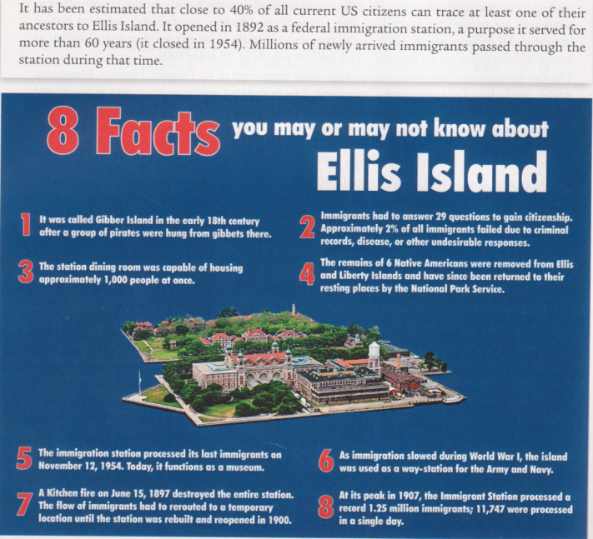
- Fill in the grid below:
- Pay attention to the numbers and their references and fill the grid +-Pay attention to dates and their references and fill the grid
DATES

NUMBERS

- Thanks to all the information find these elements:

- what sort of reasons prevented people from being admitted ?
- What happened during WWI ?
- Which facts show that Ellis island is a very important place in American heritage ?

3. THEME 2: An old culture
- Anticipate
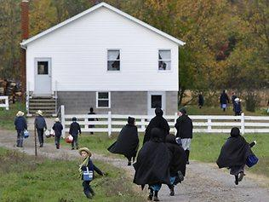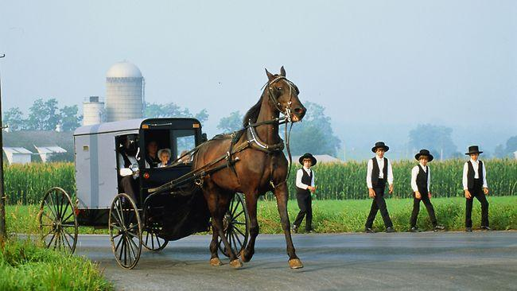
- Look at these pictures and describe what you see
- Do you think these are recent or old pictures?
🡪look at the children on the first picture, they are holding a modern object find what is it?
- Can you guess their origins/culture/country?
- Do you have any information about them?

- Reading and understanding

The Amish: Last updated 2009-06-23. Partially based on The Amish In Northern Indiana, by Samuel L. Yode
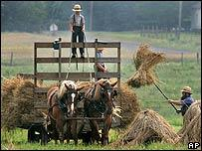
Who are the Amish?
On the surface, many Amish look like they stepped out of the rural 19th Century.
The most conservative, Old Order groups of these reclusive, religious people drive horses and buggies rather than cars. Many have no telephones or electricity in their homes. They send their children to private, one-room schoolhouses until the age of 13. They eschew technology and preach isolation from the modern world. They do not join the military or accept assistance from the government. The Amish community in Lancaster County, Pennsylvania was a model for the 1985 film Witness starring Harrison Ford, a thriller which contrasted the violent modern world with their peaceful existence. The Amish experience many of the same problems as other communities, but keep them private.
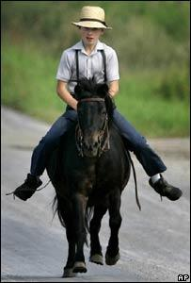
Strict regulations:
Some 200,000 Amish people live in more than 20 US states and in the Canadian province of Ontario. The oldest group of Old Order Amish, about 16,000-18,000 people, live in Lancaster County, a rural, farming area where Amish first settled in the 1720s - many fleeing religious persecution in Europe.
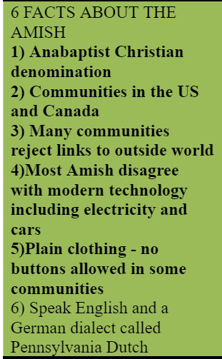
The Amish are divided into dozens of separate fellowships, broken down into districts or congregations. Each district is fully independent and lives by its own set of unwritten rules, or Ordnung.
Men and boys wear straw broad-brimmed hats
The Old Order are the most conservative of these groups, and observe strict regulations on dress, behaviour, and the use of technology, which they believe encourages humility and separation from the world. Old Order Amish women wear modest dresses with long sleeves and a full skirt, a cape and an apron. They never cut their hair, but wear it in a bun on the back of the head. Men and boys wear dark-coloured suits, straight-cut coats and black or straw broad-brimmed hats. They grow beards only after they marry. Modern technology is not rejected out of hand. Some farms have telephones and local groups can allow electricity to be used in certain circumstances.
Most Amish are trilingual. They speak a dialect of German called Pennsylvania Dutch at home, use High German at their worship services, and they learn English at school. In some ways, the Amish are feeling the pressures of the modern world.
- Read the text and fill in the grid with all these elements : location/number/language/reason of immigration/religion
Location: | Number: | Reason for coming to the USA | Language:

- Find all the elements related to their relationship with new technology/the modern world (in blue)
- Find all the elements showing their conservative features/believes (in purple) (focus on adjectives for that)
- Find all the elements related to their dress code and their appearance in general (in green)

- Writing about a subject
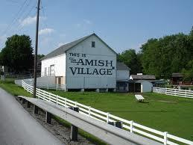
You are a journalist for a school newspaper. You are writing an article about life in an Amish village. You were invited to spend a day there. Write an article about your experience.

