GLOBAL LOGISTICS

Question 1 - Knowledge

- What are core processes in a company, in service as in manufacturing ?

Supplier relationship process
New Service product development process
Order fulfilment process
Customer relationship process

- What’s productivity formula, multifactor or labor ?

Output / Input (resources) All resources in multifactor
Labor time for labor as input

- What are steps of theory decision method ?

- List the feasible alternatives
- List the events
- Calculate the payoff
- Estimate the likelihood of each events
- Select a decision rule

- What are the five steps of the theory of constraints ?

- Identify the system bottleneck(s)
- Exploit the bottleneck(s)
- Subordinate all other decisions to Step 2
- Elevate the bottleneck(s)
- Do not let inertia
set in

- What’s basic calculation formula of Mean Absolute Deviation ?

Sum of differences squared (actual sales – forecasts) / n periods

Question 2
White Valley Ski Resort is planning the ski lift operation for its new ski resort. Management is trying to determine whether one or two lifts will be necessary ; each lift can accommodate 250 people per day. Skiing normally occurs in the 14-week period from December to April, during which the lift will operate seven days per week. The first lift will operate at 90 % capacity if economic conditions are bad, the probability of which is believed to be about 0.3. During normal times the first lift will be utilized at 100% capacity, and the excess crowd will provide 50% utilization of the second lift. The probability of normal times is 0.5. Finally if times are really good, the probability of which is 0.2, the utilization of the second lift will increase to 90%. The equivalent annual cost of installing a new lift, recognizing the time value of money and the lift’s economic life, is $50,000. The annual cost of installing 2 lifts is only $90,000 if both are purchased at the same time. If used at all, each lift costs $200,000 to operate, no matter how low or high its utilization rate. Lift tickets cost $20 per customer per day.
Select a decision method matching with this problem and solve it.

Select a decision method matching with this problem and solve it.

Alternatives/Probabilities | 30% low demand | 50% normal demand | 20%  High demand
One lift | (250x14x7x0,90) – 250 000 =  $191 000 | $240 000 | $240 000
Two lifts | $151 000  =441000-290000  Is 200 000+90000(second not used) | $245 000  0,5  -490000 | $441 000

Considering that we know the probability of each event, the Laplace decision tool is the best i.e.
191 x 0.3 +240 x 0.5 + 240 x 0.20 = 225
Or
151 x 0.3 + 245 x 0.5+441x0.20 = 256 so two lifts with $ 256 000 is the best solution

Question 3

- Total acquisition cost Whole Nature Foods sells a gluten-free product for which the annual demand is 5,000 boxes. At the moment, it is paying $6.40 for each box; carrying cost is 25% of the unit cost; ordering costs are $25. A new supplier has offered to sell the same item for $6.00 if Whole Nature Foods buys at least 3,000 boxes per order.
Should the firm stick with the old supplier, or take advantage of the new quantity discount?

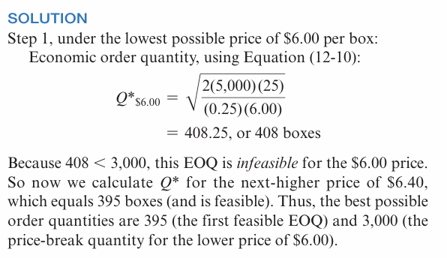

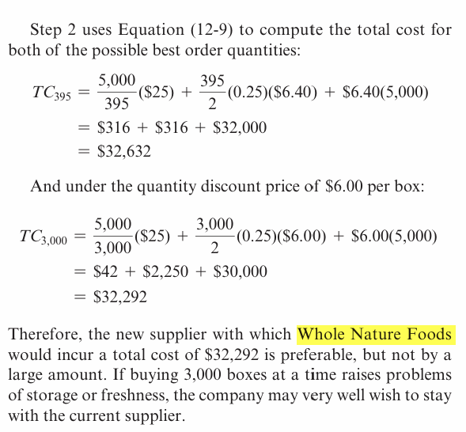

- An Apple store has a demand (D) for 8,000 iPhones per year. The firm operates a 250-day working year. On average, delivery of an order takes 3 working days, but has been known to take as long as 4 days. The store wants to calculate the reorder point without a safety stock and then with a one-day safety stock.

1-First compute the daily demand and then apply Equation (12-6) for the ROP. Then compute the ROP with safety stock.
2- If there are only 200 working days per year, what is the correct ROP, without safety stock and with safety stock?

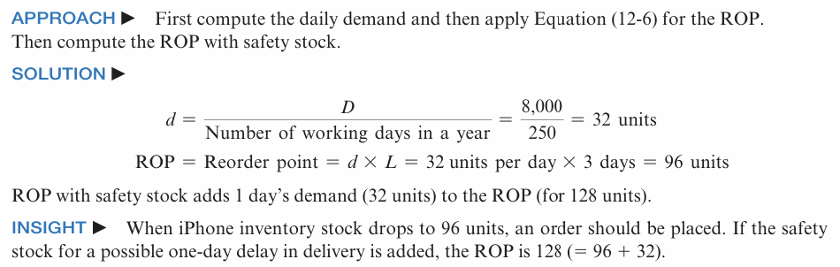

Next page turn the paper

Question 4
BOTTLENECKS

Howard Kraye’s sandwich shop provides healthy sandwiches for customers. Howard has two identical sandwich assembly lines. A customer first places an order, which takes 30 seconds. The order is then sent to one of the two assembly lines. Each assembly line has two workers and three operations:
(1) assembly worker 1 retrieves and cuts the bread (15 seconds/sandwich),
(2) assembly worker 2 adds ingredients and places the sandwich onto the toaster conveyor belt (20 seconds/sandwich),
and (3) the toaster heats the sandwich (40 seconds/sandwich). Finally, another employee wraps the heated sandwich coming out of the toaster and delivers it to the customer (37.5 seconds/sandwich).
A flowchart of the process is shown below. Howard wants to determine the bottleneck time and throughput time of this process.
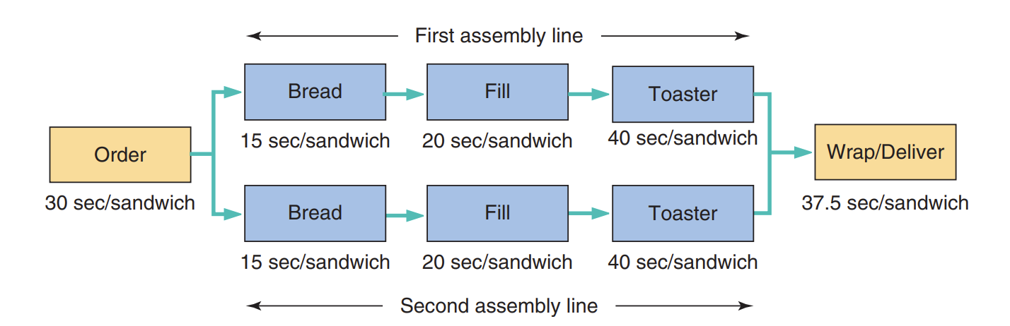
Clearly the toaster is the single-slowest resource in the five-step process, but is it the bottleneck? Howard should first determine the bottleneck time of each of the two assembly lines separately, then the bottleneck time of the combined assembly lines, and finally the bottleneck time of the entire operation. For throughput time, each assembly line is identical, so Howard should just sum the process times for all five operations.

